as-built crane specification

product range - Knuckle Boom Crane
product reference - EHC 200/4300 OS KB

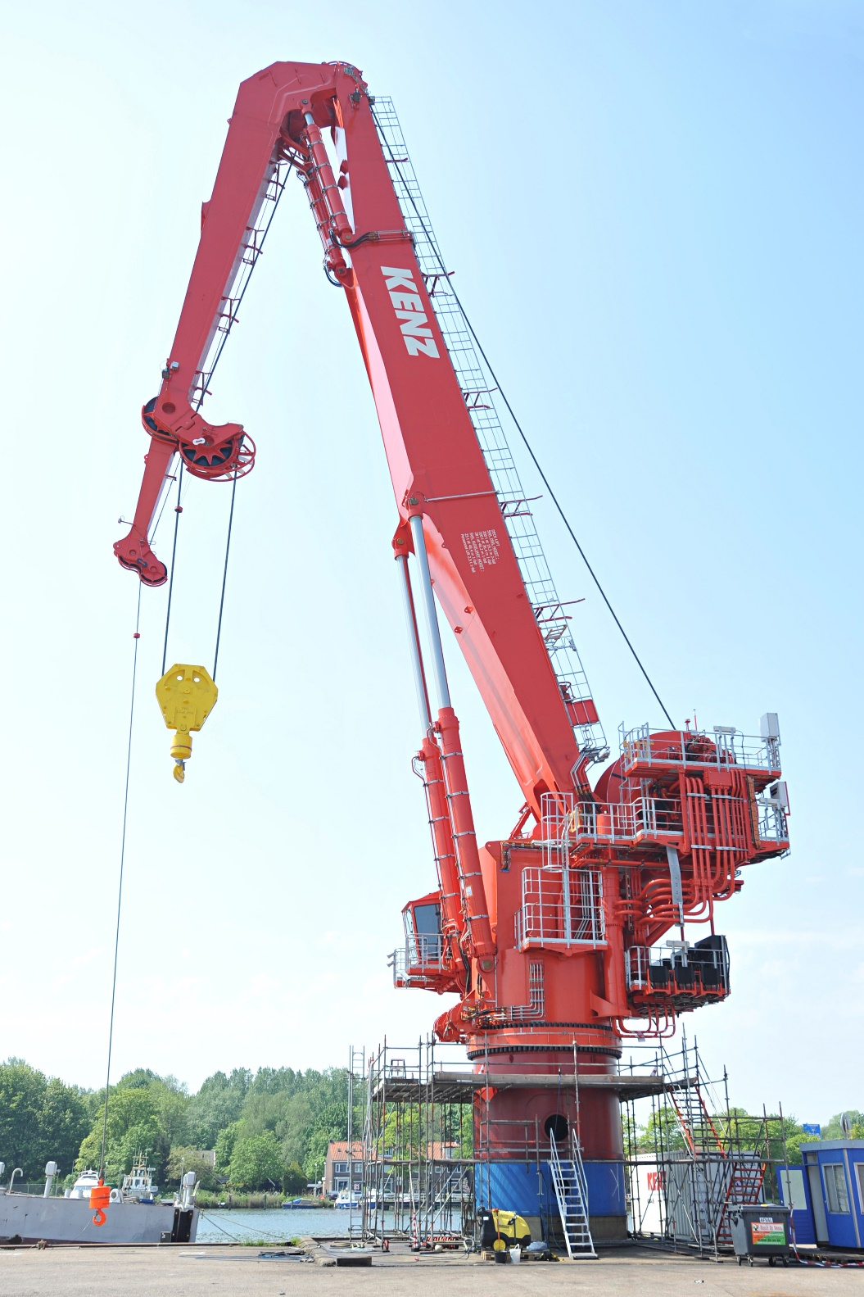

PERFORMANCE

 | Lifting/Load Capacity |  | (heel/trim - 3°/2°)
 | Main Hoist |  | Onboard SWH=0m: 2-fall, 200t @ 20m // 1-fall, 100t @ 37m
 |  |  | 100t weight in air / 80t submerged weight, lifting from 3300m water depth
 | Aux. Hoist |  | Offboard SWH=2m: 1-fall, 25t @ 47m
 |  |  | 25t weight in air / 20t submerged weight, lifting from 100m water depth
 | Tugger Winch |  | 2-off, 0-10t including constant tension, 1-fall
 | Hook Speeds |  | Variable load dependent speed, step-less from zero to maximum
 | Main Hoist |  | Offboard lifts |  | Onboard Lifts
 | Fall arrangement |  | 1-fall | 2-fall | 1-fall & 2-fall
 | Speed @ max. SWL 1st layer [m/min] |  | 29 m/min | 15 m/min | Reduced to 50% of normal speeds
 | Speed @ max. SWL last layer [m/min] |  | 45 m/min | 22.5 m/min | Reduced to 50% of normal speeds
 | Speed @ empty hook last layer [m/min] |  | 120 m/min | 60 m/min | Reduced to 50% of normal speeds
 | Aux Hoist
 | Speed with maximum SWL [m/min] |  | 40 m/min
 | Speed with empty hook [m/min] |  | 100 m/min
 | Tugger Winch |  | 75m/min constant tension speed
 | Active Heave Compensation
 | Main hoist |  | 100t weight in air / 80t submerged weight @ 60 m/min at 3300m water depth
 |  |  | Empty hook @ 90 m/min at 3300m water depth
 | Slewing |  | Three row roller-bearing
 | Slewing Range |  | n x 360°.
 | Slewing speed |  | Up to 1.0 rpm
 | Modes of operation |  | Deck lift operations
 |  |  | Barge lift operations
 |  |  | Supply boat operations
 |  |  | Personnel lift operations
 |  |  | Subsea operations

DESIGN CRITERIA

 |  | Design
 |  | Classification by |  |  | Lloyds Register
 |  | Main Design Codes |  |  | LR CLAME, 2016
 |  |  |  |  | NMA, DSB regulations concerning deck cranes on mobile offshore units
 |  | Crane Duty-Cycle Classification |  |  | according FEM 1.001
 |  | Class of Utilization |  |  | U5
 |  | State of loading |  |  | Q1
 |  | Group classification for Crane |  |  | A4
 |  | Classification of Mechanisms: |  |  | Aux. hoist |  | Main hoist | Slewing |  | Luffing | Folding | Tuggers
 |  | Duration of use |  |  | T5 |  | T5 | T6 |  | T6 | T6 | T2
 |  | Spectrum class |  |  | L1 |  | L1 | L1 |  | L1 | L1 | L3
 |  | Group classification for Mechanism |  |  | M4 |  | M4 | M5 |  | M5 | M5 | M3
INTERFACE DATA

 | Weights
 | Crane gross measured mass |  |  |  |  | 443t (1000m wire, excluding factors)
 | Delta 3380m – 1000m wire |  |  |  |  | 64t
 | Pedestal |  |  |  |  | Subject to height, deck interface and access
 | Pedestal Dyn. Overturning moment |  |  |  |  | (at slew bearing level, 88t @ 25m, SWH2m Barge Lift, +/- 5%, factored load incl wind)
 | Max. Dyn. Overturning moment |  |  |  |  | 64000kNm
 | Max. Dyn. Axial Force |  |  |  |  | 7100kN
 | Max. Dyn. Radial Force |  |  |  |  | 1500kN
 | Max. Dyn. Slewing Moment |  |  |  |  | 9100kNm
 | Power Unit |  |  |  |  | S1 |  |  | S6 |  | Starting method
 | Main Power |  |  |  |  | 3 x 400kW (S1-100%) |  |  | 3 x 560kW (S6-10%) |  | Star/Delta
 | Emergency Power |  |  |  |  | 1 x 100kW (S1-100%) |  |  |  |  | DOL
 | Utilities |  |  |  |  | Power and signals via slip ring
 | Main Power |  |  |  |  | 440V / 60Hz, 3-ph (3-off main driver motor)
 | Auxiliary Power |  |  |  |  | 440V / 60Hz, 3-ph (for Lighting & heating, Air conditioner and Power socket)
 | Emergency Power |  |  |  |  | 440V / 60Hz, 3-ph (for Emergency pump motor and Crane control system)
 | UPS |  |  |  |  | 230V / 60Hz, 1-ph (Aircraft warning lights)
 | Power consumption
 | Main |  |  |  |  | 3 x 680kVA intermittent, 3 x 485kVA continuous
 | Auxiliary |  |  |  |  | 21kVA
 | Emergency |  |  |  |  | 125kVA
 | UPS |  |  |  |  | 72VA

